**G.R.A.S.P**:

**The Grip Rectifying Assistive Sensor Pen**

Austin Adams Mayur Bhise Rushikesh Sankhye

Adams.au@northeastern.edu Bhise.m@northeastern.edu Sankhye.r@northeastern.edu

Shirish Kumar Smruti Suresh Jack Bauer

Kumar.shir@northeastern.edu Suresh.sm@northeastern.edu Bauer.ja@northeastern.edu

**ABSTRACT**

***Handwriting is a vital skill essential for everyday communication. Although it comes easily and naturally for most, proper handwriting posture can be difficult for many people, especially young children to learn. We aim to design an assistive technology that allows a user to receive live feedback on their writing posture through the use of sensors at key points of the writing process. We hope through this device, a user will be able to learn proper handwriting posture independently or in a classroom setting.***

1. INTRODUCTION

Our idea to design this assistive device came from reaching out to teachers from Damascus Elementary School, a kindergarten through eighth grade school in Damascus, Pennsylvania. We were able to identify a kindergarten girl in the school’s special education class who has difficulties holding onto writing objects. Her lack of fine motor skills was so severe that her teacher had to physically hold her hand anytime she was required to write.

Handwriting may seem trivial for many people. It is something most people do everyday and likely never think much of because we were taught it a long time ago. It is crucial to learn this at a young age. This condition, known as dysgraphia, is a neurological disorder that generally appears when children first learn to write.

Through reaching out to both the identified girl’s teacher, Mrs. Kate Killam, and the school’s Occupational Therapist, Mrs. Maureen Hunter, we were able to get a better idea of the issues this girl faces and the impact our proposed device could have.

Mrs. Killam explained that fine motor control, used for actions such as cutting, writing, and buttoning, is a major issue in kindergarten. Some children entering school have never received prior teaching and haven’t worked on at home when it comes to fine motor skills. Mrs. Hunter identified fine motor issues when it comes to writing as placing fingers at the correct position on the pencil, exerting appropriate force between the fingers and the pencil, and using appropriate force between the pen and the paper.

Although there are many different ways to hold a pencil that are deemed appropriate, the most common one typically taught in school is the tripod grip. Developmentally, children begin grasping objects with immature grips, such as a fisted grip or using all their fingers on a pencil. As they get older, they transition into what is known as a tripod grip. This consists of the pencil resting on the middle finger, and the thumb and index finger supporting the pencil on each side.This results in a comfortable grip with precise control of the pencil. The fingers control the movement of the pencil, removing any strain that would be on the wrist or arm.

Pressure between the fingers and the pencil plays an important role in handwriting posture. Too much force will result in sloppy handwriting and strain in the muscles over long periods of writing time. Too little force will cause the pencil to be loose, making writing poorpoor, and lead to the pencil falling out of the child’s hand. Use of appropriate grip force will not only ensure the best script possible, but also ensure that the writer is comfortable throughout the process.

Correct paper to pencil force is key to proper handwriting posand positioning suitable force allows for clean and legible handwriting. An excessive amount of force increases writing time, causes hand strain, and can damage the writing utensil. Inadequate force will cause the handwriting to be illegible. An appropriate balance is needed for correct writing.

Our aim was to design an assistive device that can monitor these three key areas of proper handwriting skills. We combined these values with real-time feedback so that the user can adjust their writing habits to be appropriate. Our objective was to build this device such that it could be used by people who struggle with learning these fine motor skills in an individual or classroom setting, and learn how to write properly.

1. LITERATURE REVIEW

Dysgraphia, also known as Developmental Coordination Disorder (DCD) affects nearly 20%-30% of school aged children [1]. There are two approaches to studying this problem, a biomechanical study of handwriting and studies conducted by Occupational Therapists. At present there is consensus among both the communities about the parameters that affect handwriting; namely grip strength, grip force variation and pen tip pressure.

Of these, grip strength is arguably the most debated parameter. Prunty et al. (2020) claimed that there is no difference in grip strength between children diagnosed with DCD and the control group [2]. A 2017 study by Lin et al. also backs this up with results indicating peak and average grip forces might not be direct indicators of handwriting performance [3]. On the other hand, Alaniz et al. (2015) claimed that using Occupational Therapy to train the motor aspects of handwriting (as opposed to fine motor control), resulted in better handwriting scores. The study further correlates the findings with grip strength being an indicator of pencil control and handwriting legibility [4].

Grip force variability has been shown to correlate strongly with handwriting quality with more static grip force patterns being associated with poorer handwriting. The grip force variations are the fine motor control aspects related to the manipulation of the pen which may be crucial when children are establishing their handwriting capabilities [3], [5].

The most commonly used treatment approach at present takes two approaches: multi-sensory and motor. motor encompasses the motor components of muscles and joints in the production of handwriting including strength, grip, and fine motor skills[6]. Difficulties in producing fluid and quick handwriting has been observed in children with difficulties in motor control [7].

At present there have been few efforts to give real time feedback to a child during writing. Kakhar et al. (2010) proposed JollyMate; an assistive technology developed for young children with Dyslexia. JollyMate uses simple handwritten character recognizers created using the Lipi IDE tool from the Lipi Toolkit project, for detecting when a character has been written incorrectly. If the letter is correct, visual feedback is provided [8]. Another solution similar to JollyMate proposes a learning system which combines visual, auditory and vibrational feedback to produce a multimodal system [9].

Employing any learning system with handwriting recognition either requires expensive on-board hardware in writing tools or use of digital writing devices like tablets and special pens. This drives up the cost and makes it less accessible for everyone. Furthermore, handwriting skills acquired in the context of digital tablets do not necessarily transfer over to conventional non digital formats.

Surface pressure exerted on paper is composed of two components, an axial component along the axis of the pen and a component normal to the paper. The normal component can easily be determined if the orientation of the pen – determined by its inclination – is known. In the human writer, the average orientation angle of the pen depends on hand anatomy and on personal preference, and variations seldom exceed a maximum amplitude of ten degrees in the normal cursive handwriting size, which is about 2.5 mm for an <a>, on average. Therefore, it is not a parameter which is to be controlled [10]. There has been research indicating the efficacy of using feedback to help users self-regulate the surface pressure applied on the surface using sounds, with the surface pressure being associated with sound volume [11], [12].

The authors of this paper propose an assistive technology that can help record mean grip forces on the pen and instantaneous vertical surface pressure to give real-time feedback to the user and give Occupational Therapists access to data about the child’s grip force remotely by uploading this data wireless on a server. Visual and haptic feedback are proposed in this prototype solution to help the child self-regulate surface pressure with intuitively designed feedback.

1. PROPOSED SOLUTION

Our proposed solution to combat difficulties in writing posture is G.R.A.S.P: Grip Rectifying Assistive Sensor Pen. It is a modified pen with 3D printed features and sensors for measuring data. These sensors will monitor readings of the three key components of proper writing posture. They will measure finger positioning, contact force between fingers and the pen, and contact force between the pen and the paper in addition to writing angle. Based on these input values, the pen will give a live output to the user showing whether they are within the appropriate criteria for handwriting or if they need to adjust their writing habits.

To ensure compatibility of the pen with the hand, we built a pen attachment such that the form factor of the pen does not increase drastically. The sensors do not interfere with the fingers while writing, to have a pleasant writing experience.

* 1. Detecting Finger Positioning

To detect correct finger positioning our design has force sensors located at the points on the pen that correspond to the points necessary for tripod grip. The 3D printed grip attachment was designed so that the pen can be held properly only by using tripod grip. This ensures that when the user holds the pen correctly, the three sensors will begin reading pressure values.

When all three pressure sensors read values, it indicates that the user’s fingers are orientated accurately. When this happens an LED light will flash violet, signifying to the user that they have satisfied the first criteria. If any of the three fingers are not in the correct spot, the LED will display no color. The user then knows they have to change their positioning in order to write properly.

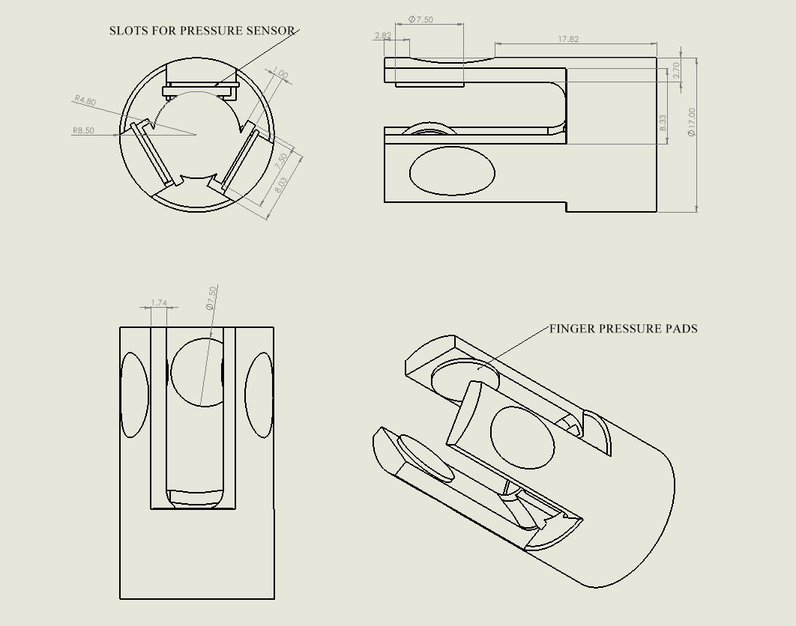

*Fig. 1.1 - Finger Positioning Component*

* 1. Finger to Pen Force

Our design focuses on modularity as we want the circuits to be easily swappable, accessible and incorporate finger to pen force by building off of the pressure sensors used in the finger positioning phase of the design. In this phase, the values read by the sensor will determine the output feedback of the device. We will test the pressure values of the course of a writing session in order to determine what threshold values are appropriate for pen gripping, what is too much force, and what is too little force.

The user’s average grip force will determine what output the pen will show during the session. If the grip force falls in the proper threshold range, which is calibrated by averaging the sensor force samples from a number of individuals to get an approximate value of what a normal force on a pencil is, the device will produce a constant green light on the same LED. An excess or inadequate amount of force will coincide with a red light or a blue light, respectfully. The visual feedback of the LED will indicate to the user whether or not they need to make adjustments to their grip force throughout their writing session.

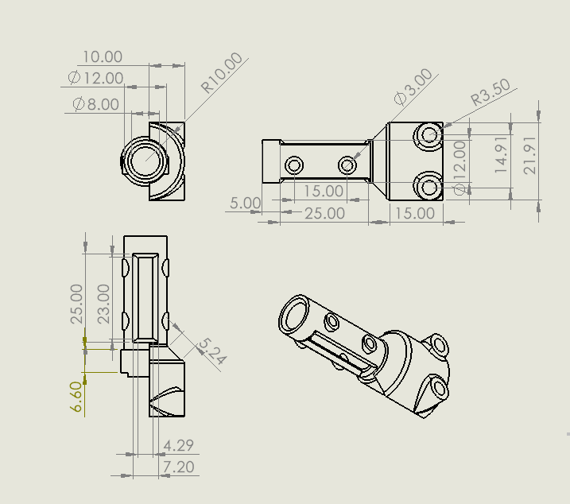

*Fig. 1.2 - Hub for IMU and Pen Paper Pressure Sensor*

* 1. Paper to Pen Force

Our design will measure and report back accurate measurements of the paper to pen force with the help of two sensors. The first of which is an additional pressure sensor located inside a 3D printed backing piece of the pen. We have a spring at the tip of the pen which pushes the ink cartridge back to apply a constant force. When the user presses the pen to the paper, the inkwell of the pen presses against the force sensor. The sensor will then measure the amount of force along the direction of the pen.

The second sensor used to measure the paper to pen force is an IMU. The IMU is also placed inside the backing piece and will measure the orientation of the pen relative to the normal axis of the writing surface. This is known as the incident angle.

Given the incident angle and the force along the axis of the pen, we are able to calculate the paper to pen force, the force normal to the writing surface using geometry.

$F_{n}=F_{p}cos(Ө)$

Where $F_{n}$ is the force normal to the surface (the paper to pen force), $F_{p}$ the force along the pen measured by the pressure sensor, and theta is the incident angle determined by the IMU. This is shown in Figure 2.

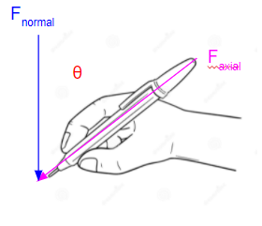

*Fig. 2 - Paper to Pen force*

Our pen will measure this $F_{n}$ value throughout the writing process, and based on deemed appropriate threshold values, report back to the user instantaneously whether or not the current paper to pen force is correct. Similar to the finger to pen force, an LED will be provided in the pen design that will give visual feedback based on the measured value. Green LED light will signify correct force values. Blue light will be displayed if the force is not enough, and red light will be displayed if the user is applying too much pressure on the writing surface.

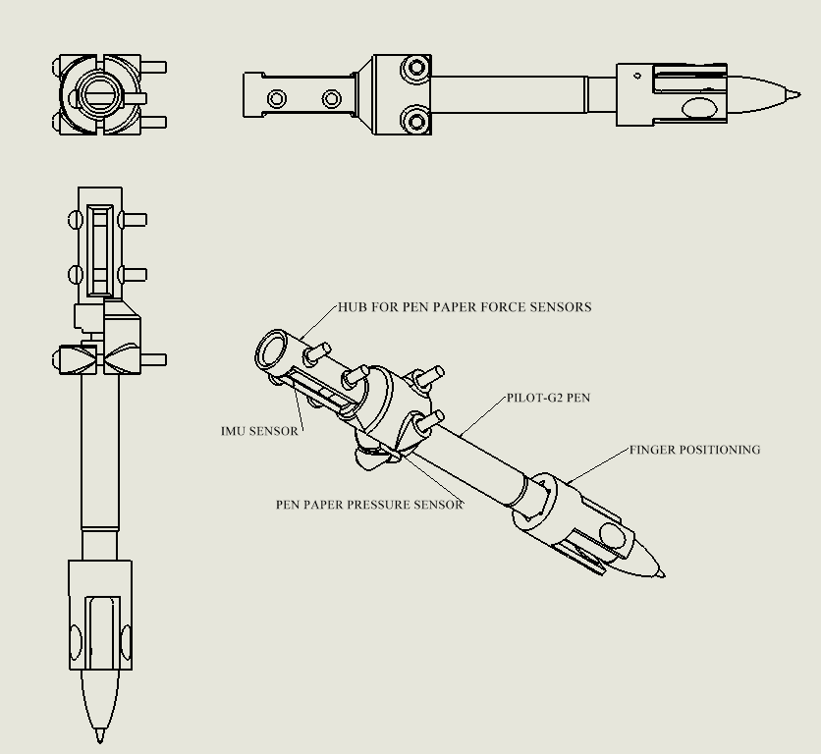

*Figure 1.3 - 2D Sketch of G.R.A.S.P*

1. SETUP
2. Prototype Setup

The G.R.A.S.P prototype utilizes the ESP32-WROOM-32D as the microcontroller of our device. This model was chosen for its wide array of analog to digital pins to read the voltage inputs from our force variable resistors. In addition, this nodemcu dev board includes the ESP32 chip which is a module with wifi and bluetooth capabilities, allowing us the freedom to flex between a direct connection and an online upload. It can receive a large range of 1.5v-12v of input and has two VCC output pins including a Vin pin that matches the output of the battery or a standard 3.3v output. For this application we utilized the Vin pin as our VCC to the system with 5v of input powering the device. The ESP32 microcontroller operates with dual CPU cores and can adjust its clock frequency from 80MHz to 240MHz.

To sense the user our prototype has two types of Force Variable Resistors (FVR) placed in voltage divider circuits to provide a variable voltage input to our MCU’s analog sensor pins. The two FVR’s we used in our device are the DF9-40 and SEN-09673. The SEN-09673 has an operation range of 1MΩ down to 2.5kΩ when 10N of force is applied to the sensor pad. It has a small form factor of 7.62mm in diameter and is the primary sensor we used to measure actuation force between the user’s fingers and the pen’s grip. The SEN-09673 was placed in series with a 4.7kΩ resistor which gave our voltage divider circuit an input measurement range of 0.22v to 3.26v to our MCU. Alternatively, the DF9-40 boasts a higher precision with a wider range of resistance varying from 10MΩ to 10kΩ. Putting this sensor in series with a 10kΩ resistor gave us a voltage operating range of 0.05v to 2.5v as an input sensor measurement to our MCU. In addition, the DF9-40 has a slightly larger form factor with a diameter of 10mm which was perfect to fit the cross sectional size of our pen base. This sensor was used to measure the pen-tip force of our device by being placed between the ink-cartridge and our 3D printed back plating.

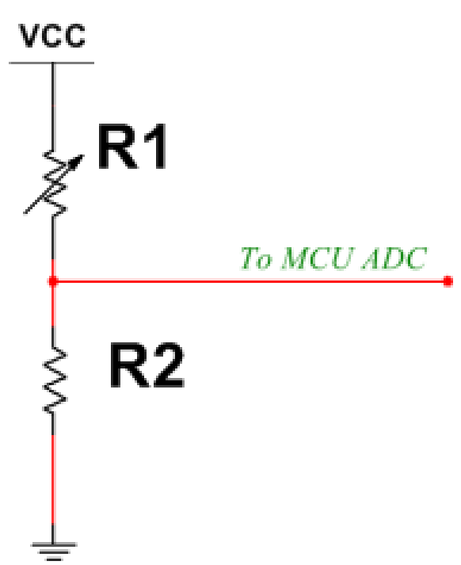

*Fig. 3 - FSR Voltage Divider Circuit*

Another capability of our device was to detect the orientation of the pen throughout its operation. This was done with the GY-521 IMU which houses an onboard MPU-6050 processor. This IMU has an accelerometer in addition to a gyroscope which provides 6 DOF measurements that can be easily used to find the orientation of the sensor.

To display our sensor inputs and feedback results we used three different components. The first is the RuiLing Micro Flat Vibration Motor which is a haptic feedback component operating at 12000rpm at 3v across its terminals. This device was used to vibrate at different speeds varying with how much excess pressure was being delivered to the pen-tip sensor. In addition, we used a common anode LED to indicate our threshold values of the pen-tip force of our device. This provided simple, visual feedback to the user without requiring their full attention. Finally, our last component was an arduino i2c LCD screen used to display digital sensor values and the tilt angle of the device. This was used to free up the COM port associated with our device while testing, and is not projected to be included in the finished product.

These components come together with our 3D printed parts to form our G.R.A.S.P device. The final wiring diagram of our prototype can be seen below in Figure 4.

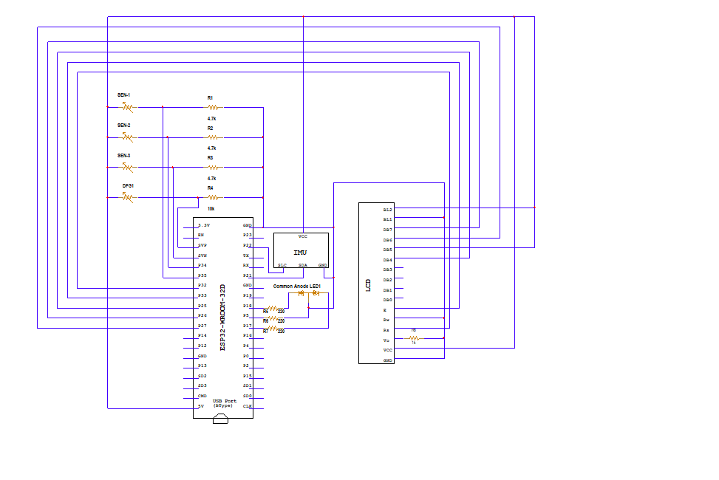

*Fig. 4 - Wiring Diagram for G.R.A.S.P Device*

1. Data Visualization Setup

We used ThingSpeak, an IoT (Internet of Things) analytics platform to visualize and analyze the data we acquired from the sensors. ESP32 is a wifi module that can implement TCP/IP among other protocols. It can act as both client and server. In our application, we use ESP32 as the client and ThingSpeak as the server. ESP32 reads Sensor Values in the form of analog readings, parses them into the required format which can be a MQTT topic, JSON or CSV files and posts these values to ThingSpeak using WRITE API KEYS. Each Sensor has a “field” allotted to it where the values are plotted against time. All this data is stored in a unique private channel which can be made public if required. ThingSpeak improves accessibility which is the most important factor for any Assistive Technology. The occupational therapist does not have to be present in person to analyze the child’s handwriting and can go back to the data at a later time to analyze it and come up with better suggestions or methods to improve the child’s handwriting. Another advantage is that ThingSpeak allows you to collaborate with multiple apps or softwares like MATLAB and social media platforms which gives you a variety of options to visualize, analyze and share the data.

1. TESTING

First step in testing involves making sure that the fingers are positioned correctly. This was done via force sensors to get accurate readings. An initialization light is used to provide real-time feedback to the user. When the pen is booted, it starts calibrating and jumps into initialization mode. It will continue blinking purple (Fig. 5.1) until the user’s fingers are in the correct position applying the appropriate amount of grip to be able to hold the pen comfortably for proper writing posture. Once this happens, the LED turns blue. (Fig 5.2)

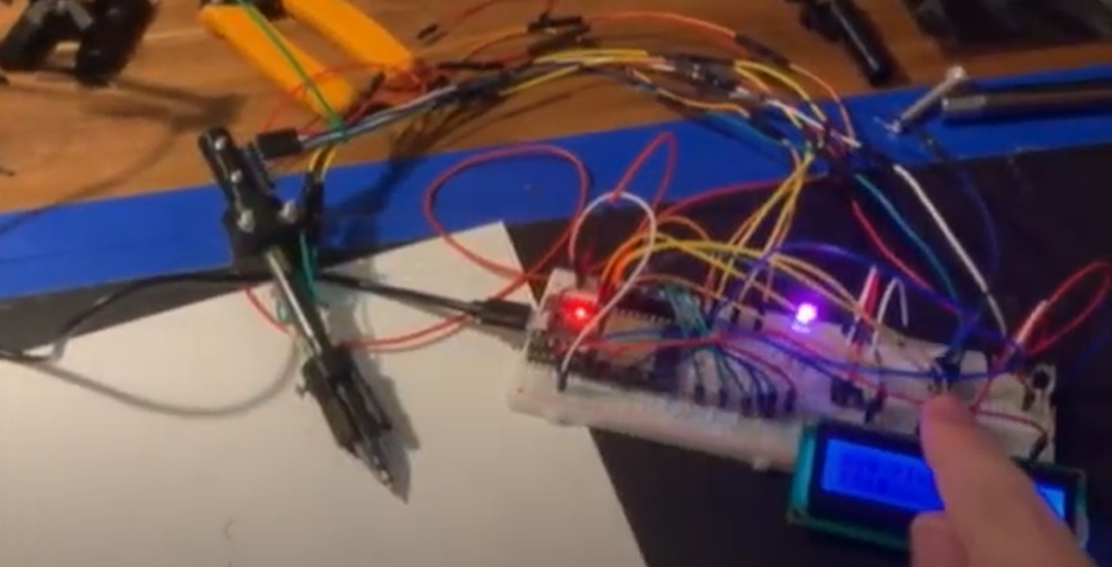

*Fig. 5.1 - Initialization Mode*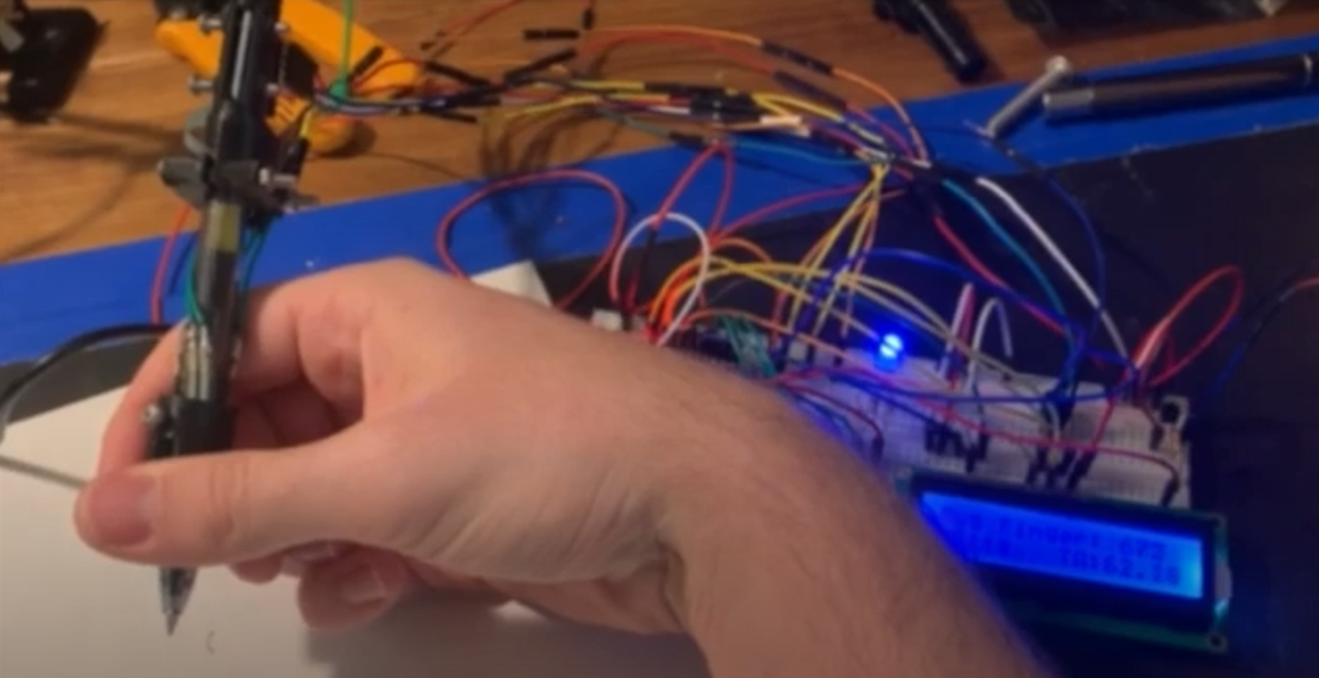

*Fig. 5.2 - LED glows blue when fingers are in the correct position.*

The axial forces are then normalized by using the angle of inclination from the IMU. This normalized force is the amount of pressure one applies on a paper which children, our target audience generally cannot regulate. If the user applies an appropriate amount of surface pressure, the LED glows green as shown in Fig. 5.3. However, if the user applies excess pressure, they are alerted via the LED which glows red as shown in Fig. 5.4.

In addition to this, the pen also consists of a vibration motor which vibrates at a frequency proportional to the amount of excess pressure on the paper. The purpose of the motor is to provide haptic feedback to the user to help them reduce the amount of pressure they apply on the paper while writing.

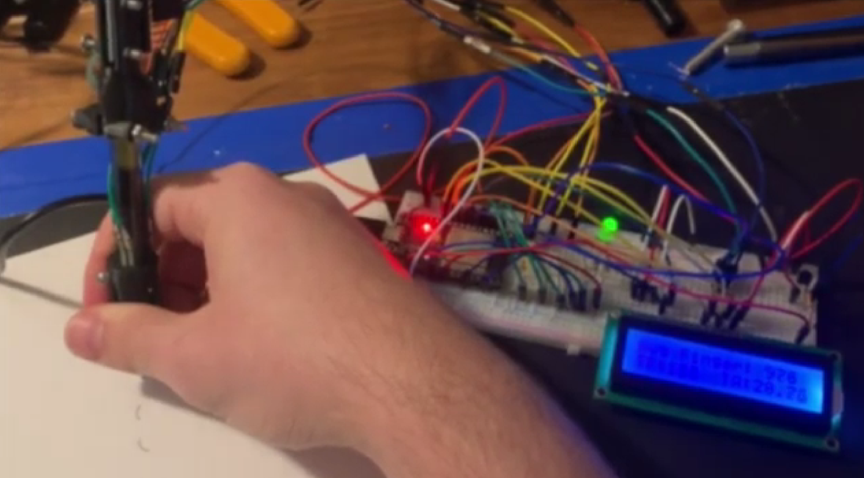

*Fig. 5.3 - LED glows green when appropriate amount of surface pressure is applied.*

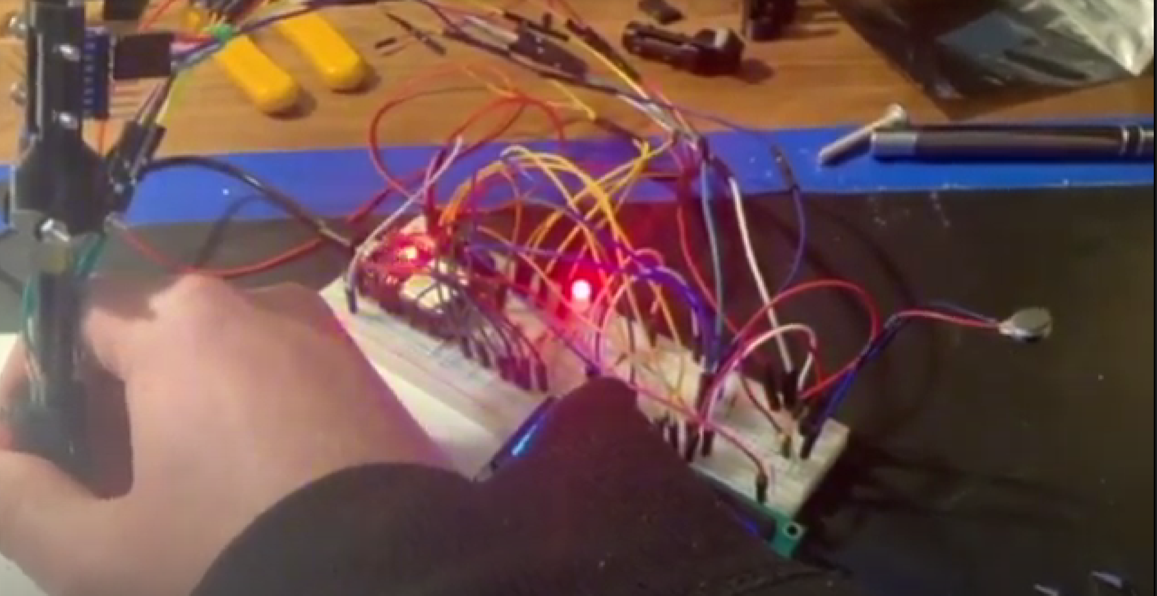

*Fig. 5.4 - LED glows red when excess pressure is applied.*

Each participant of the handwriting trial wrote the same piece of information to maintain consistency. The participants wrote with their left and right hand in order to compare good handwriting with relatively bad handwriting. All the participants were right-handed. Since it was challenging to write with their left-hand, the participants wrote only one sentence. The various sensor values were read in the form of analog readings by the microcontroller and sent to the ThingSpeak server where the values were plotted against time in the form of a 2-D line plot.

Apart from natural writing, we also captured data from four special cases:

1. **Improper grip force and improper pen tip force:** Force applied on the grip and the force applied by the tip on the paper was weak.
2. **Proper grip force and improper pen tip force:** Usual force was applied on the grip but the force applied by the tip on the paper was weak.
3. **Improper grip force and proper pen tip force:** Force applied on the grip was weak but usual force was applied by the tip on the paper.
4. **Extreme grip force and extreme pen tip force:** Excess force was applied on the grip and the paper.
5. RESULTS

Due to small sample size, it is hard to make any direct conclusions on correlation. However, it can be observed from Fig 6.2

that the finger force applied on the pen while writing with the right-hand varies considerably more compared to the left-hand. Despite the variations, the sample written with the right-hand is more legible as seen in Fig. 6.1. The same can be observed for the other factors (Angle and Tip Force) as well. This reiterates the key role fine motor skills play in handwriting.

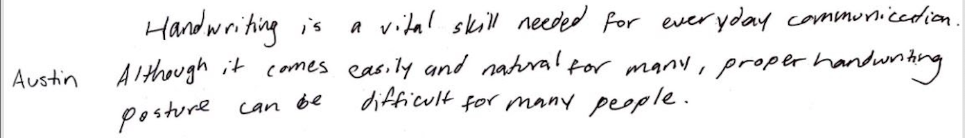

*Fig. 6.1- Participant 1’s handwriting sample for the right hand.*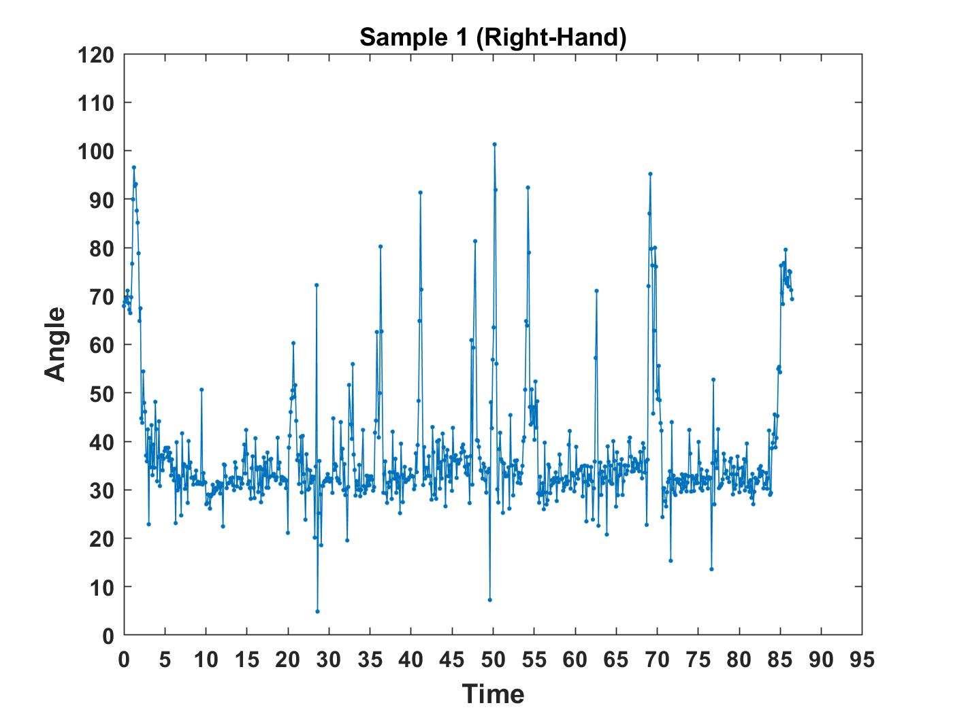

*Fig. 6.2 - Angle vs Time plot for participant 1 when they wrote with their right hand.*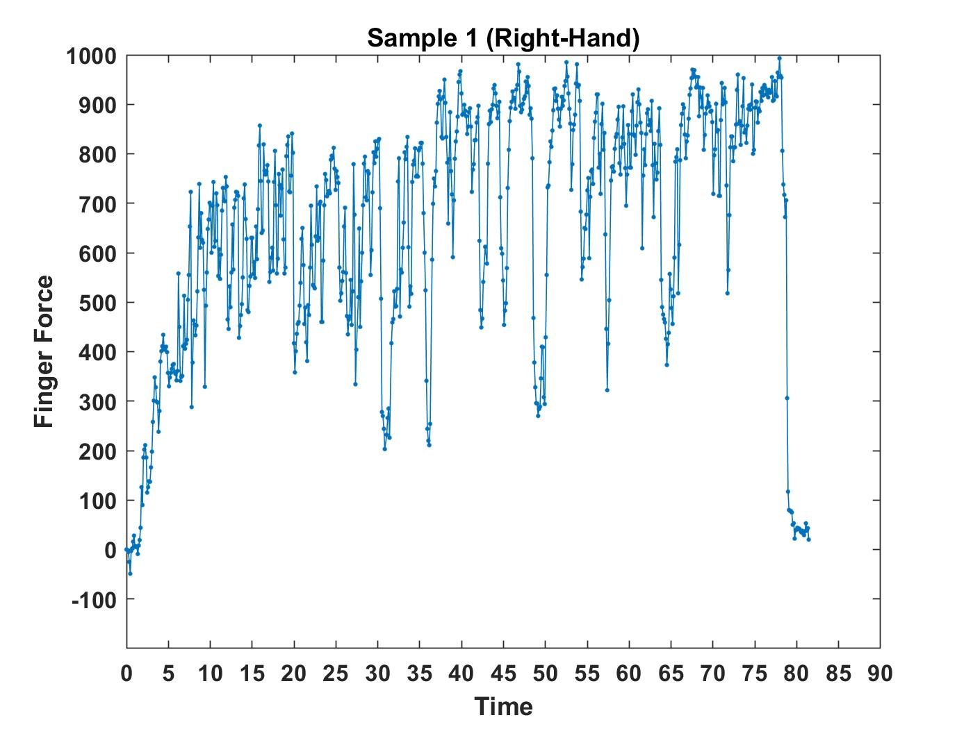

*Fig. 6.3 - Finger Force vs Time plot for participant 1 when they wrote with their right hand.*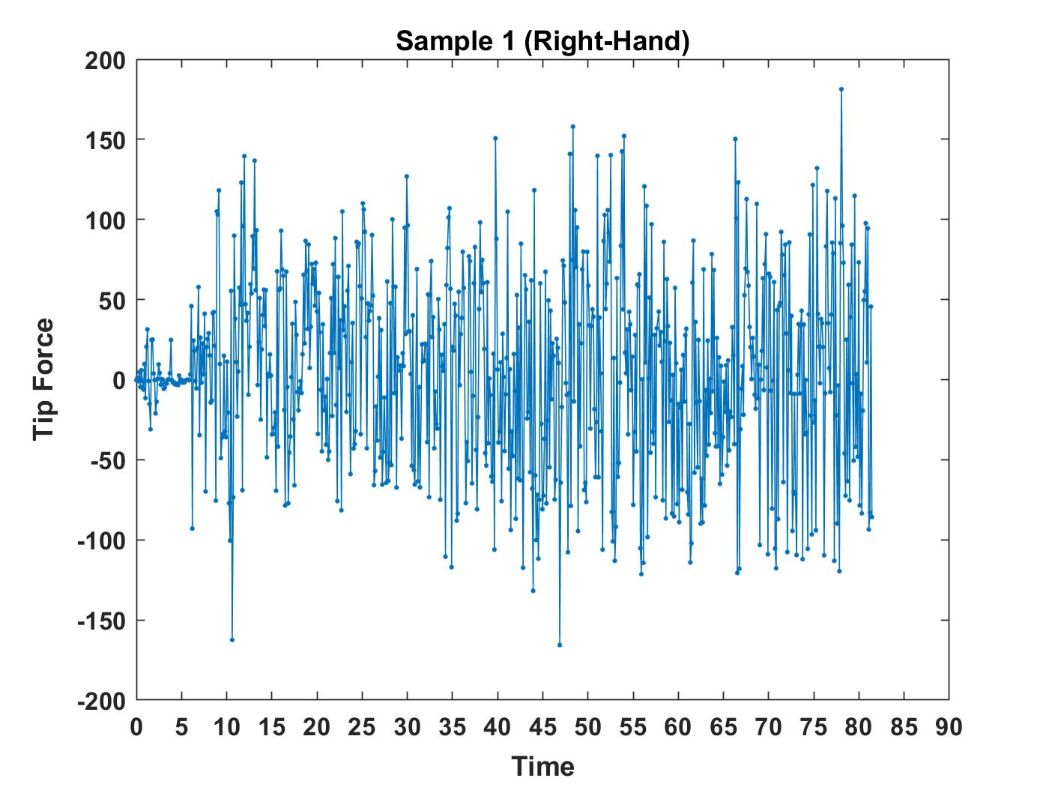

*Fig. 6.4- Tip Force vs Time plot for participant 1 when they wrote with their right hand.*

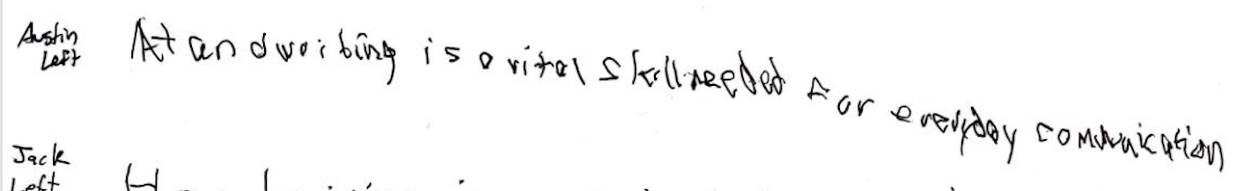

*Fig. 7.1- Participant 1’s handwriting sample for the left hand.*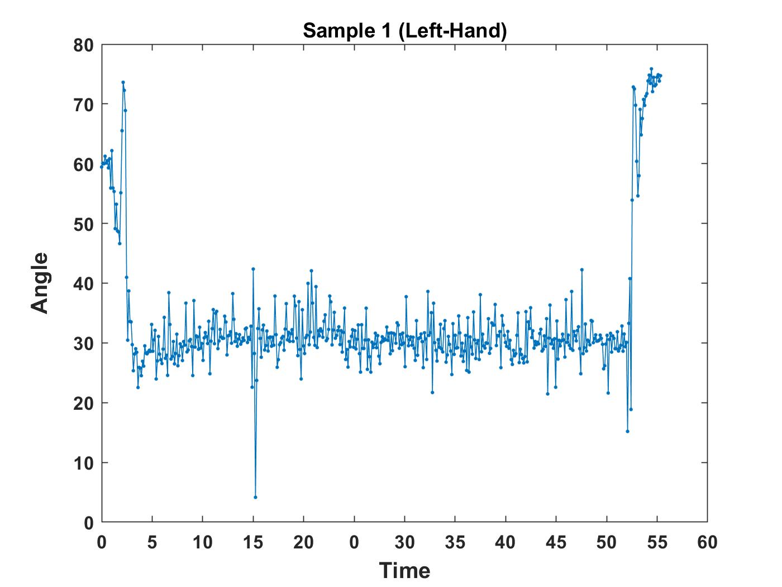

*Fig. 7.2- Angle vs Time plot for participant 1 when they wrote with their left hand.*

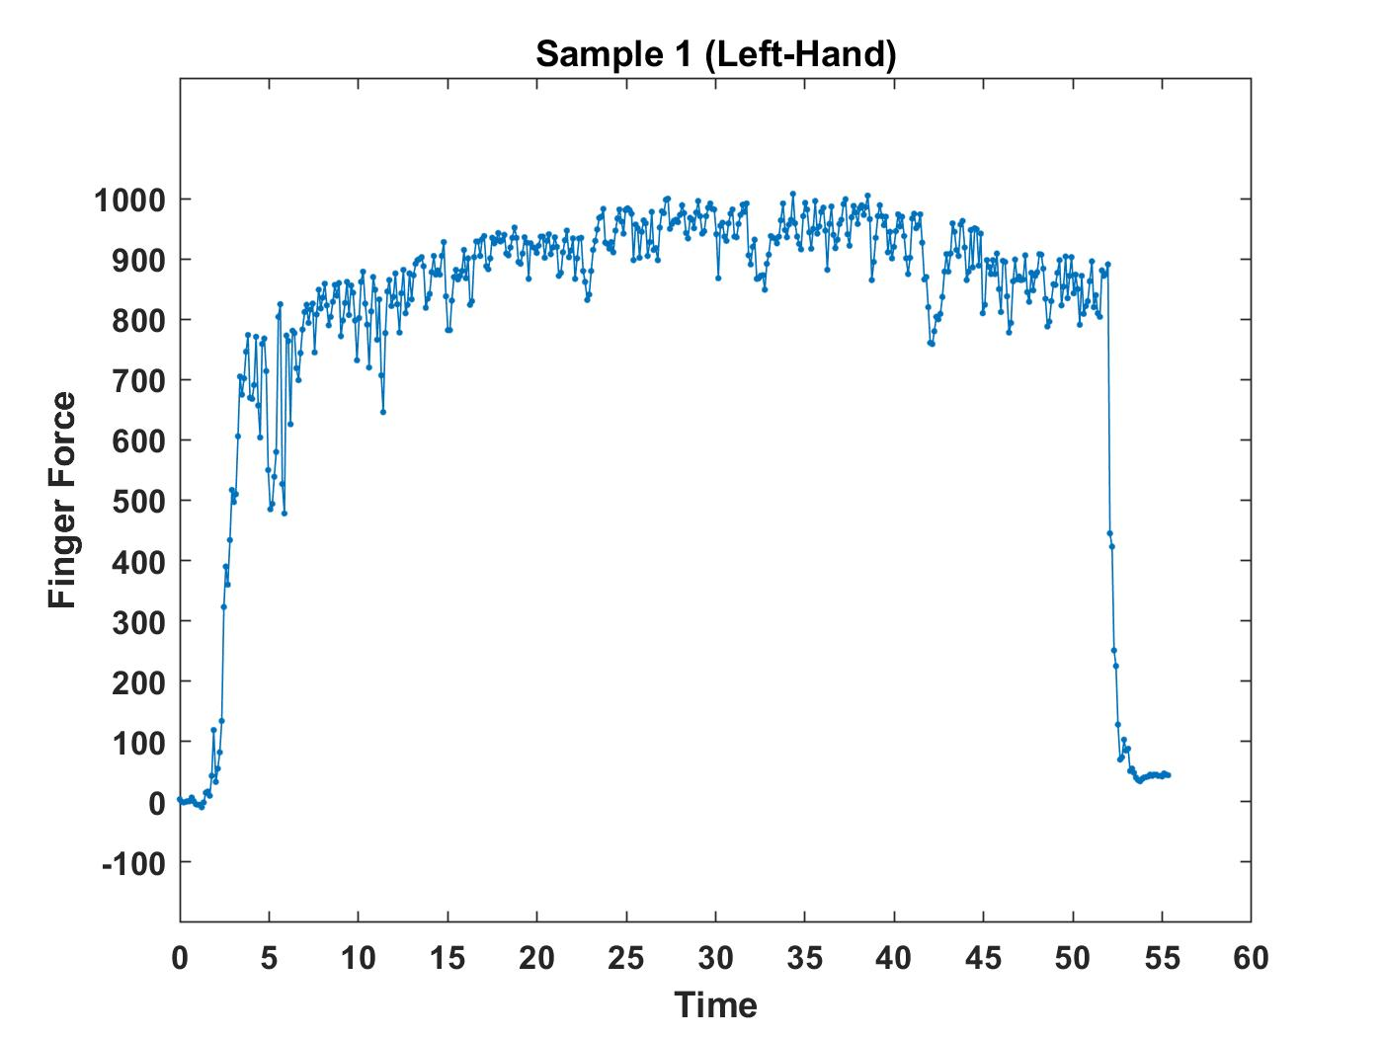

*Fig. 7.3: Finger Force vs Time plot for participant 1 when they wrote with their left hand.*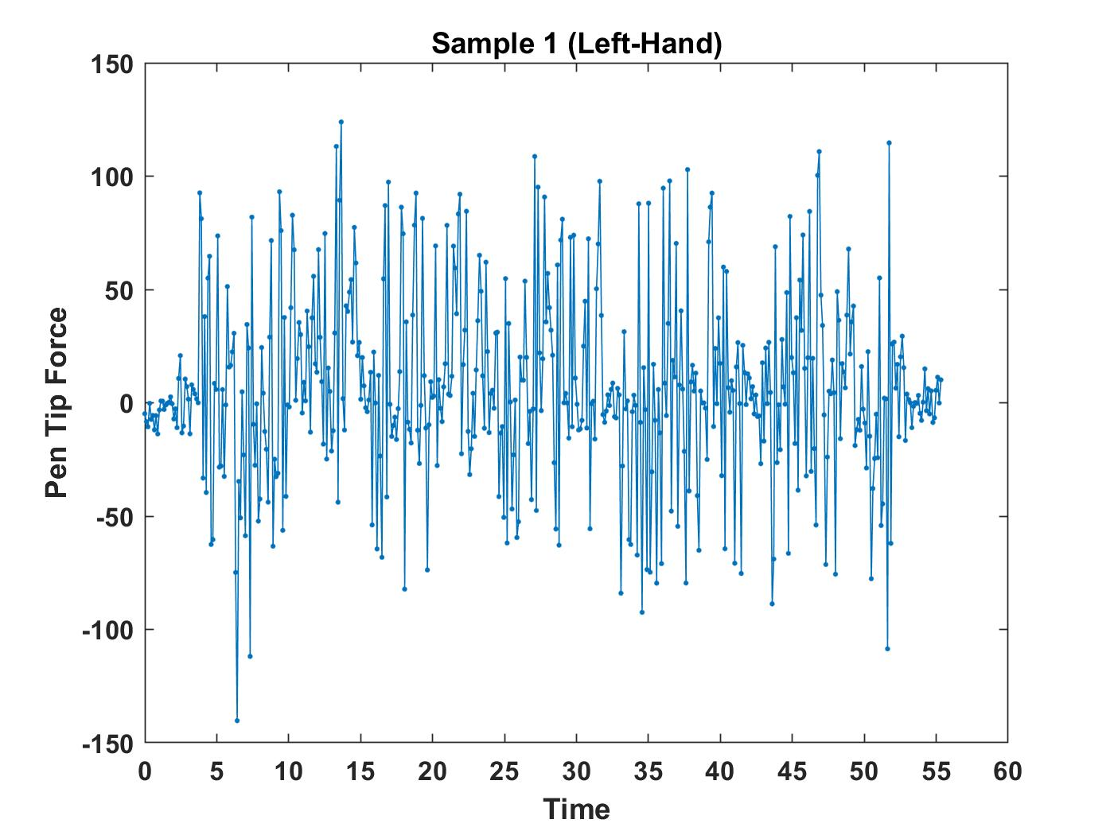

*Fig. 7.4- Tip Force vs Time plot for participant 1 when they wrote with their left hand.*

The handwriting samples and graphs for the four special cases mentioned in the Testing section can be found in the Appendix.. While we cannot make any concrete conclusions, we are confident that a professional can use the data and its visualization to identify the child’s problem area more efficiently. The graph plotted out when the child is writing can be compared to these graphs and used to zone in on what the child finds challenging.

1. CONCLUSION

G.R.A.S.P was successfully able to carry out the two main tasks outlined at the beginning of the project. Our prototype is capable of live measurements of finger positioning, finger to pen force, and finger to paper force, the three main components of proper handwriting posture. In addition the prototype also has the ability to take those measurements and both report them back in real time to the user and to an online resource for recording.

Our group was able to collect data from a small sample size of participants, although no concrete conclusions can be made, more testing can be done and that data can be reviewed by a professional in order to see if that data we have collected correlates to what is understood in the field.

Future works for this project would include large amounts of testing, particularly in our target demographic of young, kindergarten level children.

Other future works regarding this project includes, designing the pen to be more ergonomic to be comfortable while writing during long sessions, so as the user does not experience fatigue, also we’d like to share the data with occupational therapist’s working on the same problem, to be better able for understanding the results, and testing it with kids having motor function disability having difficulty with writing, implementing handwriting recognition to get an accuracy score for the targeted goal of handwriting.

Overall, the project proved to be an informative study into assistive technologies and handwriting skills. The prototype design is a solid base with the potential to fleshed out further in a variety of ways. Our group believes that if our design continues to expand, it has the potential to grow into a standalone product with the ability to impact many people.

* 1. REFERENCES

[1] K. Feder, A. Majnemer, and A. Synnes, “Handwriting: Current Trends in Occupational Therapy Practice,” *Canadian Journal of Occupational Therapy*, vol. 67, no. 3, pp. 197–204, Apr. 2000, doi: 10.1177/000841740006700313.

[2] M. M. Prunty, A. Pratt, E. Raman, L. Simmons, and F. Steele-Bobat, “Grip strength and pen pressure are not key contributors to handwriting difficulties in children with developmental coordination disorder,” *British Journal of Occupational Therapy*, vol. 83, no. 6, pp. 387–396, Jun. 2020, doi: 10.1177/0308022619885046.

[3] Y. C. Lin *et al.*, “Comprehension of handwriting development: Pen-grip kinetics in handwriting tasks and its relation to fine motor skills among school-age children,” *Australian Occupational Therapy Journal*, vol. 64, no. 5, pp. 369–380, Oct. 2017, doi: 10.1111/1440-1630.12393.

[4] M. L. Alaniz, E. Galit, C. I. Necesito, and E. R. Rosario, “Hand Strength, Handwriting, and Functional Skills in Children With Autism,” *The American Journal of Occupational Therapy*, vol. 69, no. 4, pp. 6904220030p1-6904220030p9, May 2015, doi: 10.5014/ajot.2015.016022.

[5] T. H. Falk, C. Tam, H. Schwellnus, and T. Chau, “Grip force variability and its effects on children’s handwriting legibility, form, and strokes,” *Journal of Biomechanical Engineering*, vol. 132, no. 11, Oct. 2010, doi: 10.1115/1.4002611.

[6] A. Piller and E. Torrez, “Defining Occupational Therapy Interventions for Children with Fine Motor and Handwriting Difficulties,” *Journal of Occupational Therapy, Schools, & Early Intervention*, vol. 12, no. 2, pp. 210–224, 2019, doi: 10.1080/19411243.2019.1592053.

[7] S. H. Chang and N. Y. Yu, “Characterization of motor control in handwriting difficulties in children with or without developmental coordination disorder,” *Developmental Medicine and Child Neurology*, vol. 52, no. 3, pp. 244–250, Mar. 2010, doi: 10.1111/j.1469-8749.2009.03478.x.

[8] J. Khakhar and S. Madhvanath, “JollyMate: Assistive Technology for Young Children with Dyslexia,” in *2010 12th International Conference on Frontiers in Handwriting Recognition*, Nov. 2010, pp. 576–580. doi: 10.1109/ICFHR.2010.95.

[9] R. Brondi, M. Satler, C. A. Avizzano, and P. Tripicchio, “A multimodal learning system for handwriting movements,” in *Proceedings - 2014 International Conference on Intelligent Environments, IE 2014*, Sep. 2014, pp. 256–259. doi: 10.1109/IE.2014.48.

[10] L. R. B. Schomaker and R. Plamondon, “The Relation between Pen Force and Pen Point Kinematics in Handwriting.”

[11] Danna Jérémy *et al.*, “Handwriting movement sonification for the rehabilitation of dysgraphia,” in *10th International Symposium on Computer Music Multidisciplinary Research (CMMR)-Sound, Music & Motion*, Oct. 2013, pp. 200–208.

[12] J. Danna *et al.*, “The effect of real-time auditory feedback on learning new characters,” *Human Movement Science*, vol. 43, pp. 216–228, Oct. 2015, doi: 10.1016/j.humov.2014.12.002.